Farmer Plus
Requirements Specification Document

06/Nov/2010
FAST – NUCES

Project Advisor
Sir. Waqar Ahmed

Project Team
Qasim Ifzal – L080969
Amber Shahid – l095061
M.Zubair – l080808
Tahir Rauf – l095068

Revision History

Date | Version | Description | Author
01-Nov-2010 | 0.1 | Initial Draft | Amber Shahid
05-Nov-2010 | 0.2 | Initial Review | Amber, Qasim, Zubair, Tahir

Table of Contents
1. Introduction 4
1.1 Purpose 4
1.2 Scope 4
2. Overview 4
3. Process Flow 5
4. Business Requirements 6
5. User Requirements 7
6. Functional Requirements 9
7. Non-Functional Requirements 9
8. Hardware Requirements 9
9. Software requirements 9
10. Actors 10
11. Use-Cases 10
UC 11.1.1 C 10
12. Traceability Matrix 10
13. System Architecture Diagram 11
14. Data Model 11
14.1 Data Flow Diagram of Screen Designer 11
14.2 Data Dictionary 11
15. GUIs 12
UC 15.1.1 C 12
16. References 12
17. Glossary 12

Software Requirements Specification

Introduction

Although Agriculture Industry is a large part of Pakistan’s economy, not much research has been done in providing up to date information & facilities to the farmers working in this sector in every corner of Pakistan. Therefore, we will develop an SMS (Short Message Service) & IVR (Interactive Voice Response) facility system that will provide our farmers ready information (e.g. Hourly weather forecast, Weekly weather forecast, Temperature, Precipitation, Humidity etc.) whenever they need it.

Purpose

This document discusses detailed requirements of Farmer+ system which will be used as basis for the design. The purpose of this document is to enable application architects and software developers to understand required functionalities of the system and develop a viable solution. Business, User, Functional & Non-Functional Requirements will be covered in this document.

Scope

This document explains the basic flow of the system, all types of requirements of the system to be developed, use cases, traceability matrix and relevant diagrams.

Overview

Pakistan's principal natural resources are arable land and water. About 25% of Pakistan's total land area is under cultivation and is watered by one of the largest irrigation systems in the world. Agriculture accounts for about 23% of GDP and employs about 44% of the labor force.
Since the agriculture industry is a major part of Pakistan’s economy; up to date information needs to be provided to farmers where ever they may be present. Computers are one option for accessing information provided either on a CD or via the Internet. But computers are not always readily accessible by small-scale farmers and most of our farmers are not computer literate as well. Web-based mobile phones with Internet access provide another option but, again, not many farmers have such phones or Internet connectivity.

However, one alternative is available to many small-scale farmers: mobile phones with SMS (short message service) capability. With such mobile phones, text messaging and call centers are options for getting information to farmers. Another way to reach many farmers with mobile phones is through interactive voice response (IVR). With IVR, a farmer calls a phone number with a voice recording that presents a menu of questions about the farmer’s rice field and growing conditions. The farmer answers each question by pressing an appropriate number on the keypad. Once all questions are answered, the farmer receives a text message with a guideline on the amounts, sources, and timings of fertilizer application for his or her specific field.

Since not much research or work has been done in this field in Pakistan, we plan to provide substantial help to the farmers via this SMS & IVR system to produce more food with higher profitability.

Process Flow

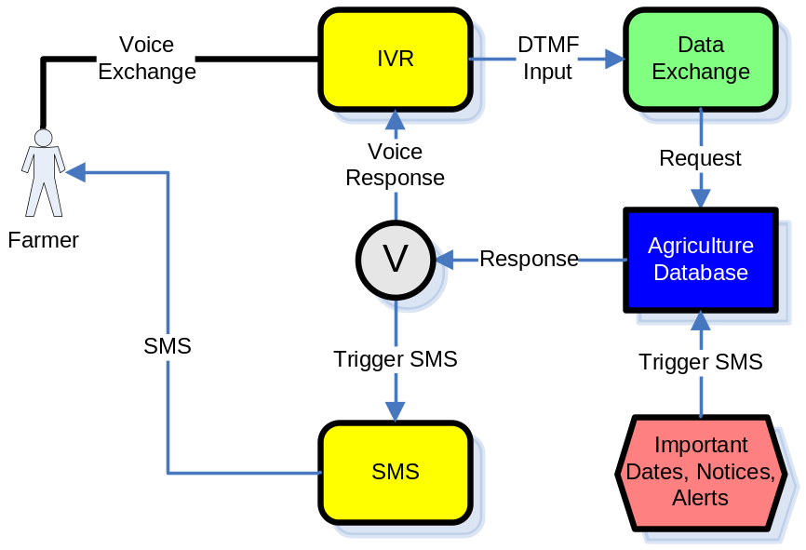

Business Requirements

- Develop a system to access accurate, up-to-date & timely information, via SMS & IVR, to assist farmers in decision making.

- Information services and facilities provided by the system should include:
- Rates Information
- Cultivation Information
- Support facilities
- Complaint Lodging
- Registration facilities

- System should have two types of SMSes services:
- Push-type SMSes are sent regularly or when certain criteria are met, as specified by the user
- Pull-type SMSes are sent on the user’s request by SMS.

- System should have two types of IVR services:
- Push-type IVRs are sent regularly or when certain criteria are met, as specified by the user
- Pull-type IVRs are sent on the user’s request as a talkie.

- System should provide multilingual access to information and services.

- The developed system should be easily usable by the farmers of Pakistan.

User Requirements

- User shall be able to make a call on Farmer+ help line number.

- User shall be able to hear a talkie message on his cell phone.

- User shall be able to send an SMS on the Farmer+ Help Line number when a need arises.

- User shall be able to receive an SMS from the Farmer+ Help Line number.

- No SMS received by user shall be more than 5 lines of the mobile screen.

- Text of SMS received by user shall be in Urdu and digits in English.

- Font size of SMS received by user shall be medium so that it is readable by the user.

- User shall be able to know rates of 5 crops and 1 other crop.

- User shall be able to know rates of 5 location pesticides and 1 other pesticide.

- User shall be able to know rates of 5 location fertilizers and 1 other fertilizer.

- User shall be able to know rates of 5 location seeds and 1 other seed.

- User shall be able to know rates of 5 agricultural equipments and 1 other equipment.

- User shall be able to get rain, wind and other weather information daily.

- User shall be able to get rain, wind and other weather information weekly.

- User shall be able to lodge a complaint if the purchasing for 5 location crops and one other is delayed.

- User shall be able to lodge a complaint if the pricing for frequent purchases is unfair for the farmer.

- User shall be provided advises for 5 season crops and other crop for cultivation.

- User shall be provided advises for 5 latest market items and 1 other market item.

- User shall be given a warning message about weather conditions.

- User shall be given a warning message about Pest attack if it is about to occur.

- User shall be given a warning message about flood if it is about to occur.

- At any time, user must be able to record a request by pressing one specific button on any menu.

User Requirement | Pull-Type IVR | Push-Type IVR | Pull-Type SMS | Push-Type SMS
U8 | Yes | Yes | Yes | Yes
U9 | Yes | Yes | No | No
U10 | Yes | Yes | No | No
U11 | Yes | Yes | No | No
U12 | Yes | No | No | No
U13 | Yes | No | Yes | Yes
U14 | Yes | No | Yes | Yes
U15 | Yes | No | No | No
U16 | Yes | No | No | No
U17 | Yes | Yes | No | Yes
U18 | Yes | Yes | No | Yes
U19 | Yes | Yes | No | Yes
U20 | Yes | Yes | No | Yes
U21 | Yes | Yes | No | Yes

Functional Requirements

- System should allow …

Non-Functional Requirements

- SMS sent by the Farmer+ system should not be more than 5 lines of the mobile screen of the farmer.

- SMS sent by the Farmer+ system shall be in Urdu and digits in English for easy understandability of the user.

- SMS sent by the Farmer+ system should have a medium Font size for easier readability of the message.
- Whenever user sends a pull-type SMS, system should respond to the received SMS within 30 seconds.

- Whenever user sends a pull-type IVR message, system should respond within 30 seconds.

Hardware Requirements

- 1 Mobile GSM device

- 1 FXO Gateway (4 port)

- 4 Computer machines (With UPS)

- 1 Network Switch & 8 Network Cables

Software requirements

- MS Project (Project Management)

- .Net 3.0 Framework (Development Environment)

- Web SVN (Configuration management)

- Testlink (Testing)

- Asterisk (SoftPBX)

- TrixBox (Wrapper for configuration of Asterisk)

- SMSLib (SMS Management)

Actors

Use-Cases

Diagram

C

Description
Actors
Pre condition
Primary Flow
Post condition
Alternative Flow
Exception
Post condition | .
Alternative Flow
Exception

Traceability Matrix

Use Case | Actor | Functional Requirements | User  Requirements | GUI
UC11.1.14 | Administrator | FR1 | UR1 | GUI 15.1.1

System Architecture Diagram

Data Model

Data Flow Diagram of Screen Designer

- Level 1.0 Basic Flow

- Level 1.1 Control Flow

Data Dictionary
Setup Table

Column Name | Data Type | Length | Allow Nulls | Description
Setup | char | 10 | No | Screen Name specified by the user

GUIs

C

References

Glossary

